The way, to get GFX from other games into your SMW-Hack:
Point 1:
Open a SMW-rom in Lunar Magic, disable "Use Joined GFX-Files" in the Options Menu
and extract the ExGFX or/and the GFX (in the File Menu).
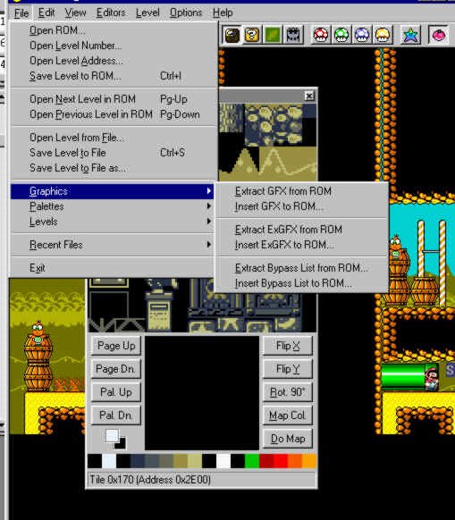
Now you have two new folders in your actual folder: Graphics and ExGraphics.
The Graphic folder contains the normal GFX Files and the ExGraphics the special
ExGFX Files from the game.
Point 2:
In the Level Menu you can found two options: "Bypass FG/BG GFX list" and
"Bypass Standart SP GFX list". You must use the FG/BG GFX list, if you want to add more Foreground and/or Background graphics in the game and you must use the SP GFX list, if you want to add more sprite graphics into the game.
Now you can open the "Bypass FG/BG GFX list"-window and enable the list for your actual level. If you have a normal unchanged Super Mario World-Rom, you have at this point no ExGFX-files in your Exgraphics folder.
The easiest way (imho) to get some ExGFX-files in this folder, open the graphics folder and choose one of the *.bin file and copy it into the ExGraphics folder. You must rename it. For example, you can call it: ExGFX80.bin. You can import your GFX-bin-file once again and you can call it ExGFX81. Now you have two bin-files, which you can use for your own Graphics. In Lunar MAgic now, in the Bypass Window choose a custom list index number like 00 for example, it's available for a new list. Don't change FG1 and FG2, these are some of the main Graphics from the game, it's better to don´t change it in the beginning ;) But you can change BG1 and BG2. In this example, choose 80 and 81, this were the new ExGFX-files. Now press OK. The graphic in that level will screw up, because you have no new Graphics inserted. For that, you need now the "Tile Layer Pro".
Point 3:
Open the Tile Layer Pro and a game.
In this example, it´s Warioland - SML3.
Pick up the GFX you want and you can see it larger in the 8x8 editor:
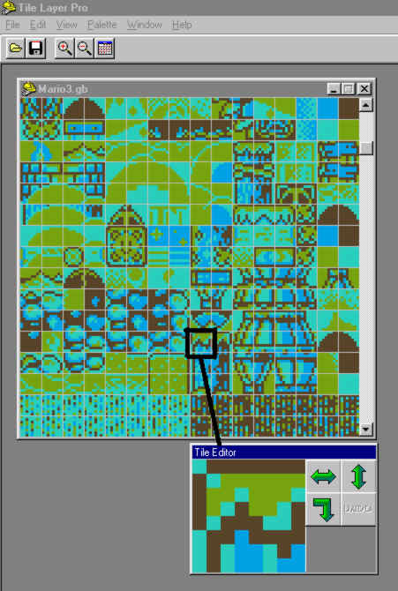
Open one of the ExGFX-bin-files in TLP. (When it says, the scrollbar is out of range, make the window smaller and it will work). You have two windows, one with the GFX from Warioland and one with your bin file. Transfer the 8x8-tile from the GFX you want in your game in the Tile Arranger-window. There are two ways to do this. One is to drag a tile from the ROM window (with left mouse button) into the arranger, and drop it at the
position where you want it. The second way is to select the tile from the ROM with the
left mouse button, then click right mouse button at the desired position in the Arranger
window. With the same method you can transfer it to your binfile!
If you have some new GFX in your binfile, save it and go back to Lunar Magic.
Point 4:
To see the changes in the game, you must insert the ExGFX back to the rom.
Open the 8x8 Tile Editor window now. Click on the "Page Down-Button" and you can see your new GFX. If you like, you can (re-) arrange it or change some things in the file.
Press F9, LM save the changes in the ExGFX-file.
To see it correctly in the game, you must insert the ExGFX back to the rom!
To use the new ExGFX correctly, you must open the LM 16x16 tile editor window!
Pick up a free place and click on the "16x16 Attributes-Button"!
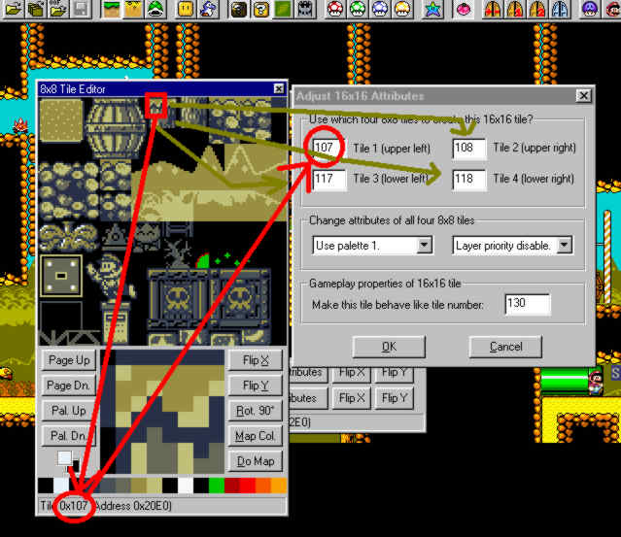
Choose the 8x8 tiles to create the 16x16 tile.
Choose the palette you want and the Gameplay properties (130 is the normal block)
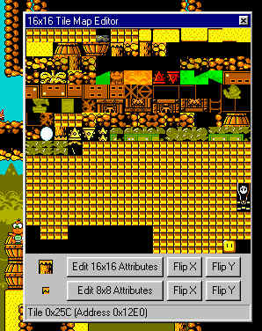
Insert the actual 16x16-tile with a right-mouseclick on a free place in the editor-window. Press F9 to save it. Finally you must insert the ExGFX-files back to the rom.
To see the GFX in the right colors, open the palette editor in Lunar Magic (and enable the custom palette).
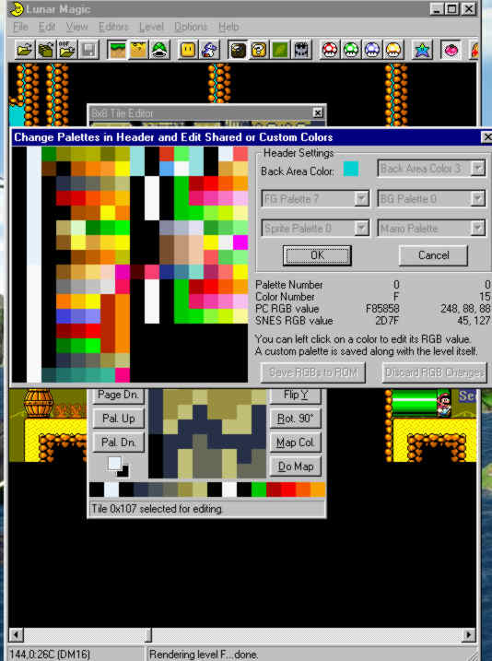
That´s all, I think... I hope you understand, what I mean. ;)
By FPI Productions

